Cromemco – History
(From www.s100computers.com)
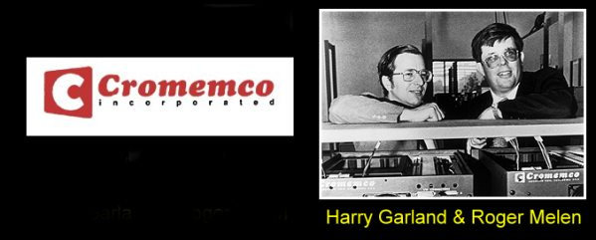
Cromemco was arguably the most successful of the S-100 companies. Their products were rock solid, pricey but very popular in certain business segments. They had the widest range of boards, systems and software of any company.
The company was started in 1975 by two Stanford University grad students, Roger Melen and Harry Garland who obtained a very early Altair S-100 computer (serial number 0002 apparently) that year. They were quite impressed with the concept of a homebrew computer and decided to to setup a company themselves. They talked with Ed Roberts/MITS and initially discussed building a kind of video camera interface board for his system. At the time they lived in the CROthers MEMorial Hall dormitory on the Stanford campus - thus the name Cromemco. In 1976 they produced an S-100 board called the Dazzler for the S-100 bus. It was the first color video board for the bus and it was a big hit. They soon moved out of the dorm and formally setup the company in nearby Mountain View CA. At their peak in the early 1980's they had over 500 employees. They tended to specialize their business in unusual areas (both in equipment, software, and business locations). Apparently at the time they were the largest suppliers of micro-computers to China. Their computers were used widely by weather forecasting groups -- somebody told me in some places they are still working and the US military.
Like TDL early on they saw the advantages of the Z80 and from the get-go based their early products around that chip. Their early S-100 systems were big computer frame mount boxes. You could drop it 10 feet and it would probably still be working. As I said above their boards were somewhat expensive and beyond the range of many homebrewers at the time. Nevertheless the range of boards they made was enormous. Later systems even evolved into non Intel CPU's systems. They had their own Z80 Assembler (excellent BTW) Basic, Fortran and many other language packages. They never did completely accept CPM but had their own "look alike" system called CDOS and a multiuser system called CROMIX. Unlike others they had an European branch that was quite successful in Germany.
In 1987 they were bought out by a company called Dynatech who had used their systems for weather forecasting on TV. The European entity survived longer and I hear has been recast in Zug Switzerland.
Cromemco had a number of complete systems over the years.
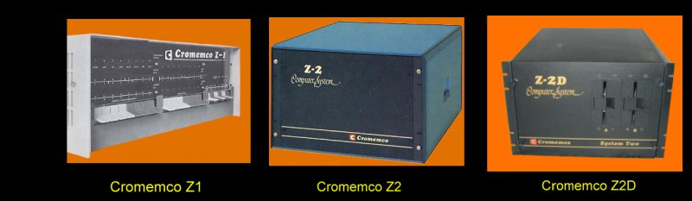
Clearly for the Cromemco Z1 they went across the San Mateo Bridge and worked out a deal with IMSAI. It was an IMSAI box re-labeled with their own Z80 CPU an 8K SRAM board, a PROM board and an IO board. The Cromemco Z-2 computer was their own first a Z80 based microcomputer system and was made for many years in forms of increasing complexity. It has a huge power supply, a rock solid motherboard and card cage. The Z-2 series was capable of supporting up to 21 S-100 boards and could be configured with any of the boards supplied by Cromemco. It had a hefty 450-watt power supply. The Z80 card was switchable for 2 or 4MHz - unusual when it first came out. and could be configured with up to 4 16K RAM cards. Typical systems had a TU-ART board, the 4FDC board and external 8" floppy disk drives. Communications was typically serial to a CRT terminal.
The Z-2D had Wangco 5" drives built in. There was an Z-2H which had a hard disk.
Cromemco then changed the outward looks and design of their systems making them less industrial looking. The System 3 and its variations is a good representation of this. Initially the System 3, which came out in 1978, had 8" Persci drives. These drives use voice coil head positioning, and were very fast. They ran two disks on a single spindle, with individual motors to load and unload the disk. However they were electronically quite complex. They became infamous because of their unreliability. Cromemco later switched to the much more reliable Tandon half height 8" drives. Nevertheless the system was well received offering a quite viable multi-user disk operating system called Cromix. A typical setup would contain a 4MHz, z80 card, a 16FDC card a few 64K or 256K RAM cards, a TU-ART card, a printer interfacer card and a hard disk controller card like a WDI-II card.
The manual for this system can be seen here.
In the early 1980's Cromemco went towards the Motorola 68000 32 bit CPU's. By this time their boards had become extremely sophisticated and their systems were comparable to mini-computer UNIX systems. These were called System 100,255 and 300. The 300 sported a S-100 IEEE-696 68000 32 bit CPU, up to 2MB RAM, and an STDC (~ESDI) hard disk controller in a 20 card slot motherboard.
